Date: October 16, 2026
Computer Engineering · Antonio Varas campus · Instructor: Arturo Guerra Castro
Group 2 · Exequiel Alvarado, Diana Guerrero, Manuel Jansen, Cristian Jorquera
APT Project: Alloxentric Generic Support Chatbot

Guía2. Desarrollo Proyecto APT
Asignatura Capstone

1. APT Project progress summary
Below are the fields completed with the requested information.

APT project progress summary | By week 11 the project has a multi-tenant conversational support platform running in production. The frontend (React 18 + Vite) and the API (FastAPI) are deployed on Vercel, and the database on Supabase (PostgreSQL 17 with pgvector). Each client company manages its documents, FAQs and website; the bot answers through two agents, a technical one and a sales one, using only that company's knowledge, and hands over to a person when it cannot solve the request.  Progress was shaped by a milestone that changed the phase: on August 28 Alloxentric delivered the system already built. The work shifted from building from scratch to verifying, fixing, completing, deploying and measuring. Within that frame, these user stories were completed, among others: multi-tenant data model and migrations (SCRUM-73), role-based authentication (SCRUM-79), text extraction, chunking and vectorization (SCRUM-85 and SCRUM-132), crawling the company website (SCRUM-24), the company's own encrypted API key (SCRUM-18), answers grounded only in the documentation (SCRUM-53), configuration of the two agents (SCRUM-91), deactivation of companies (SCRUM-151) and the conversational engine as a LangGraph graph (SCRUM-178).  The engine is now a seven-step graph: it rephrases the question, picks the agent, searches the company's knowledge base, generates the answer, verifies it, applies the business rules and, finally, checks that no concrete data (link, email, phone number, amount or percentage) reaches the customer unless it is in the knowledge base. To measure quality on a real case, Duoc UC was loaded as a test company: 172 pages from duoc.cl and 987 documents with the curricula of 95 programs, which the bot already uses to answer which courses each semester includes.  In numbers: 391 automated tests run on every change (also against PostgreSQL), 31 reviewed pull requests (30 merged) and 191 Jira issues organized in three sprints.
Objectives | The general objective stays the same, with one agreed scope adjustment: the WhatsApp channel is out of v1 (ADR 0002), because enabling it depends on Meta's verification, which the team does not control. The engine is channel-agnostic and is demonstrated through the web channel.  Adjustments to the specific objectives:  · Objective 3 (RAG engine): answers are generated with any OpenAI-compatible provider, not only DeepSeek; today Groq (gpt-oss-120b) because of its free tier, with a fallback provider for rate limits.  · Objective 4 (channels): single link and web widget in scope; WhatsApp out.  · A verifiable quality objective is added: the bot must not deliver data that is not in the knowledge base, and how often it finds the right passage must be measured.  The full scope, with what is in and out, is closed in docs/alcance.md.
Methodology | Adapted Scrum with two-week sprints is kept, adjusted in three ways:  · Planning is done on the Jira user stories (epic → story → subtask), as the instructor requested. Each pull request carries the key of the story it implements, so progress can be traced from the story to the code.  · Quality assurance became part of the flow: Cristian writes the tests for each story (PR #15 to #19), findings are fixed in their own pull requests (PR #20), and no change is merged without green continuous integration, which runs ruff and the tests on SQLite and on PostgreSQL.  · Decisions that change direction are recorded as ADRs (deployment on Vercel and Supabase, WhatsApp out of scope) instead of being settled verbally.
Progress evidence | The evidence for this progress report is the three items committed in Phase 1, plus the system evidence:  1. Repository with continuous integration: history of 31 pull requests and 166 commits, and GitHub Actions running ruff, 391 tests on SQLite and the suite on PostgreSQL with pgvector, plus the frontend build (Project Evidence › Documentation evidence). Rationale: it shows how the solution was built, not only the result.  2. Tenant isolation tests: automated tests verifying that a company never receives fragments from another, even with two companies querying the same graph at once (tests/test_semantic_search.py and test_motor_langgraph.py, included in the test report). Rationale: it is the most critical security requirement of a multi-tenant platform.  3. Indexed knowledge base: the four initial simulated companies with their knowledge, and Duoc UC with 172 pages and 987 indexed documents (Evidencias de sistema Aplicación Base de datos folder). Rationale: it shows ingestion working on real data.  4. System and database: screenshots of the application in production, deployment diagram, SQL schema, data dictionary and entity-relationship model (Project Evidence › Evidencias de sistema Aplicación Base de datos folder).  Evidence quality is safeguarded because it comes from the repository itself and from production, dated, and can be regenerated with the accompanying scripts.  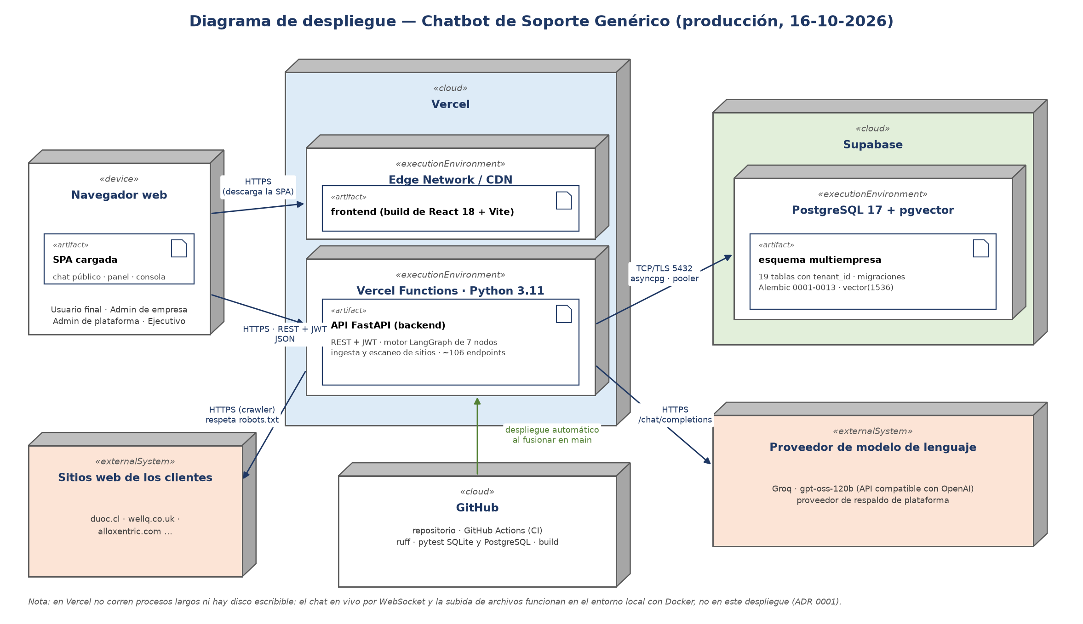  Deployment diagram (production, 2026-10-16)  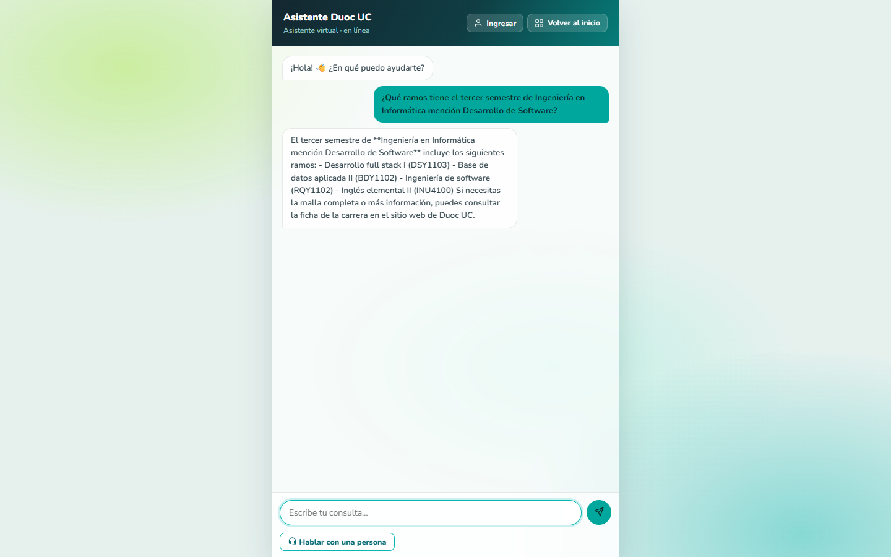  Duoc UC chat answering the courses of a semester
2. Work plan monitoring
Examina cuidadosamente tu plan de trabajo, enfocándote especialmente en la columna de estado de avance y ajustes.

Work plan
Competency or competency units | Activities | Resources | Activity duration | Owner | Observations | Progress status | Adjustments
IT project management | Project definition and planning. Jira backlog: 19 epics, 37 user stories, 18 tasks and 117 subtasks in 3 sprints. | Alloxentric functional document, Jira, GitHub | Weeks 1 to 4 | Diana Guerrero (coordination), whole team | Facilitator: complete functional documentation from the client. Obstacle: the Jira CSV importer failed several times and duplicate epics remained (SCRUM-3 to 11). | Completed | Re-planning after the August 28 base change: the backlog moved from building to verifying and completing. Cleaning the duplicate epics is set for week 12.
Software development / Data modeling | Multi-tenant functionality. Stories: SCRUM-73 data model and migrations; SCRUM-79 role-based authentication; SCRUM-12 tenant isolation; SCRUM-175 tests also on PostgreSQL. | Repository, Docker, PostgreSQL with pgvector, GitHub Actions | Weeks 5 and 6 | Exequiel Alvarado; Manuel Jansen (data model); Cristian Jorquera (authentication tests) | Facilitator: the delivered system already filtered by company. Obstacle: it had no continuous integration; it was set up first. | Completed | No RLS: isolation is filtered in the application and verified with tests; RLS is documented as an improvement (docs/alcance.md).
Data modeling | Knowledge base. Stories: SCRUM-85 text extraction; SCRUM-132 chunking and vectorization; SCRUM-24 website crawling; SCRUM-184 crawl modes; SCRUM-187 editable pages; SCRUM-42 and SCRUM-120 document upload. | Company documentation, client websites | Week 7 | Exequiel Alvarado (development), Diana Guerrero (document screens) | Facilitator: the ingestion pipeline already existed. Obstacle: Vercel has no writable disk, so file upload does not work in the deployment. | Adjusted | The knowledge base became a full CRUD with text documents from the panel (PR #23) and crawling advances in 20-second batches (Vercel limit). File upload works locally.
Data modeling | Database setup: Supabase with PostgreSQL 17 + pgvector, migrations 0001 to 0013 and demo data. Stories: SCRUM-179 the four companies in production; SCRUM-157 mismatched columns. | Supabase, Alembic, seed scripts | Week 8 | Exequiel Alvarado; Manuel Jansen (database connection, PR #10) | Facilitator: the delivered model already had tenant_id. Obstacle: vector indexing was new to the team and the HNSW index skipped the best match. | Completed | Supabase instead of a self-managed VPS (ADR 0001). «Hash» (word-based) embeddings until Azure credentials are available. Exact per-company search (PR #30).
Software development | Frontend integration. Stories: SCRUM-96 design system and role-based access; SCRUM-103 and SCRUM-141 companies; SCRUM-151 deactivate companies; SCRUM-185 ES/EN/PT; SCRUM-177 end-user history; SCRUM-29, SCRUM-131 and SCRUM-114 pending screens. | Wireframe v11, mockups, Vercel | Week 9 | Diana Guerrero and Manuel Jansen (interface), Exequiel Alvarado (integration) | Facilitator: closed wireframe. Obstacle: a PR bumped incompatible Vite and React Router versions; it was reverted before merging (PR #29). | In progress | Three screens remain in progress (agents of every company, bot agents with preview, agent management); they close in week 12.
Software development | Backend integration: handover to a person live or by ticket. Stories: SCRUM-35 talk to a person; SCRUM-137 agent onboarding; SCRUM-59 ticket when no agent is available; SCRUM-102 ask and get an answer. | Deployed API, WebSockets, Redis | Week 10 | Exequiel Alvarado (development), Cristian Jorquera (tests, PR #16 to #19) | Facilitator: it is the part best covered by tests. Obstacle: Vercel does not keep WebSocket connections open, so live chat does not work in the deployment. | Delayed | QA tests found defects that were fixed (PR #20 and #28). Live chat works locally; in week 12 the team decides whether to add a host for WebSockets or document the limit.
IT project management | First progress delivery: report 2.4, technical report 2.3, presentation and evidence. | Deployed system, Jira, repository | Week 11 | Whole team | Facilitator: work log and Jira kept since week 1. Obstacle: Jira statuses lagging behind the code. | In progress | Delivered on October 16 with the official folder structure.
Certification testing | First-delivery adjustments: address feedback and clean up Jira (statuses and duplicate epics). Story: SCRUM-176 tidy up handover tests. | Instructor feedback, Jira, continuous integration | Week 12 | Cristian Jorquera (QA), Diana Guerrero (Jira) | Facilitator: the isolation test battery is already in continuous integration. | Not started | The technical part was brought forward: PostgreSQL tests and exact search are already in production.
Software development | Language model integration: classifier and two agents. Stories: SCRUM-18 own encrypted key; SCRUM-53 documentation-only answers; SCRUM-91 two agents; SCRUM-119 classifier; SCRUM-178 LangGraph graph; SCRUM-183 answers in the customer's language; SCRUM-188 company description. | Model provider (Groq), LangChain and LangGraph | Week 13 (brought forward to weeks 7 to 11) | Exequiel Alvarado | Facilitator: the provider's free tier. Obstacle: rate limits (429) left answers unverified. | Adjusted | Replaceable OpenAI-compatible provider instead of only DeepSeek (PR #11), with a fallback provider. Engine as a 7-node graph (PR #25 and #31).
Certification testing | Final adjustments: answer quality. Relevance threshold (PR #27), exact search (PR #30), data check (PR #31), Duoc UC test company; annotated question bank and classifier confusion matrix. | Duoc UC and the 4 simulated companies, evaluation scripts | Week 14 | Cristian Jorquera (question bank), Exequiel Alvarado (engine) | Facilitator: Duoc UC provides a large real website to measure on. Obstacle: word-based search does not understand synonyms. | In progress | The engine work was brought forward; the annotated bank and the confusion matrix remain. If Azure credentials are available, embeddings change and the threshold is recalibrated.
IT project management | Second delivery: final report 2.6, deployed platform, demo video. | Platform in production, final report | Week 15 | Whole team | Facilitator: report 2.6 already has a draft with the current status. | Not started | —
IT project management | Second-delivery adjustments and closing of the technical documentation and user manual. | Instructor feedback, documentation | Week 16 | Whole team | Facilitator: decisions written down as ADRs. | Not started | —
IT project management | Final presentation: rehearsal and defense with a live demo. | System in production, slides, video | Weeks 17 and 18 | Whole team | Facilitator: the slides are kept up to date at every milestone. | Not started | —

3. Adjustments based on monitoring
Profundiza en las observaciones de tu plan de trabajo. Analiza las actividades planificadas y señala qué aspectos facilitaron u obstaculizaron la ejecución del plan. Plantea cómo abordaste y/o abordarás los obstáculos. Por último, señala los ajustes que realizaste al plan de trabajo a partir de este análisis.

Factors that have facilitated and/or hindered the development of the work plan:
Facilitators: (1) the system Alloxentric delivered on August 28 already covered much of the scope, so time could go into verifying and improving; (2) continuous integration catches regressions before merging and was extended to PostgreSQL to detect what SQLite hides; (3) the model provider's free tier allowed testing at no cost; (4) Jira with epics, stories and subtasks makes it visible who does what.

Difficulties: (1) the development load is concentrated on one person (22 of the 30 merged pull requests), which makes that person's availability a risk; (2) the free provider's rate limits (error 429) left answers unverified at peak times; (3) Vercel supports neither WebSocket connections nor a writable disk, which keeps live chat and file upload local only; (4) Jira statuses lag behind the code and the CSV importer failed several times; (5) word-based search does not understand synonyms, which lowered the quality of some answers until the content was rewritten.

Adjusted or removed activities:
· Language model integration (week 13): brought forward to weeks 7 to 11 and generalized from DeepSeek to any OpenAI-compatible provider (Groq today), with a fallback provider. Reason: the free tier allowed testing at no cost and the change avoided depending on a single provider.
· Knowledge base (week 7): became a full CRUD with text documents and batched crawling, because Vercel has no disk and no long-running processes.
· Deployment: Vercel + Supabase instead of a VPS (ADR 0001), for zero cost and simple continuous integration.
· WhatsApp channel: removed from v1 (ADR 0002), because it depends on Meta's verification.
· Answer quality (week 14): part of the work was brought forward (calibrated threshold, exact search and data check) after incomplete answers and invented data were detected in production.
· Phase 1 feedback: planning was redone on the user stories, the architecture became a deployment diagram, the scope was closed and the repository was organized according to the official structure.

Activities not started or delayed:
· Backend integration (delayed): live chat over WebSocket works locally but not on Vercel. Action: in week 12 the team decides between adding a host that keeps connections open (for example, a container on a service with long-running processes) or documenting the limit and demonstrating live chat locally. Stories SCRUM-35, SCRUM-59 and SCRUM-137 remain in progress in Jira meanwhile.
· Frontend screens (in progress): SCRUM-29, SCRUM-131 and SCRUM-114. Action: Diana and Manuel close them in week 12, reviewed by Exequiel.
· Annotated question bank and confusion matrix (planned for week 14): not started. Action: Cristian builds the bank from the companies' real FAQs and Duoc UC's curricula, whose answers are already known.
· Jira cleanup: duplicate epics (SCRUM-3 to 11) and outdated statuses. Action: Diana cleans them up in week 12 and from then on each merged pull request closes its story.

En caso de que el Proyecto APT sea grupal, en esta columna deben indicar el nombre de los responsables de cada tarea o actividad. Esto posteriormente permitirá diferenciar la evaluación por cada integrante.

